We all need Inspiration and Hope. Where will you find yours?

St George is the patron Saint of Scouting because of his one act for the greater good of many; demonstrating scouting qualities. | 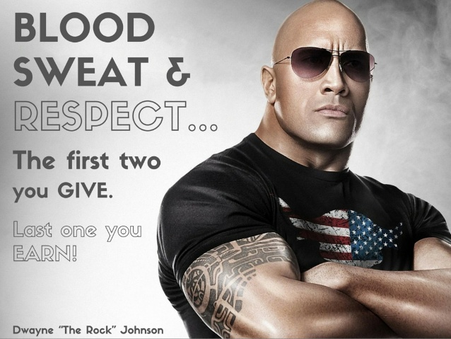 | Can you find out about two inspirational people and the words they said that inspire you?  (We’ve given you some examples to get you started).
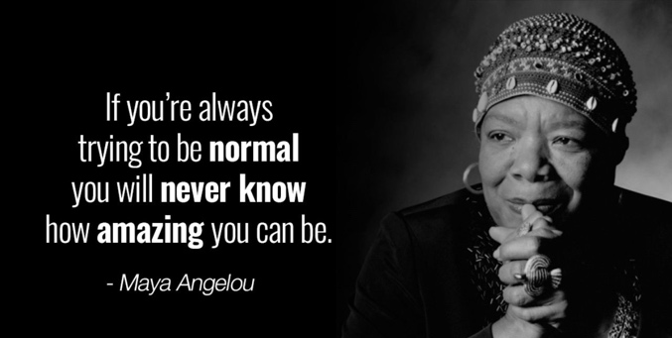 | Try to find one female and one male.  Maybe print a picture of their words for yourself?  What did they do that made them famous?  How did their words help them?  How do they link with your scouting promise? | 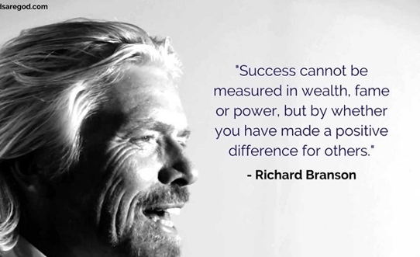
Suggestions for Inspirational People  JK Rowling  Maya Angelou  Rosa Parks  Bill Gates  David Beckham |  | More suggestions:  Marie Curie  Albert Einstein  Winston Churchill  Michael Jordon  Queen Elizabeth I

