Seeds for Bees
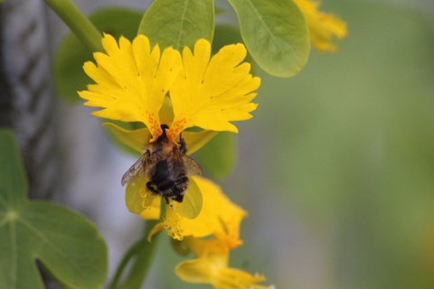 | 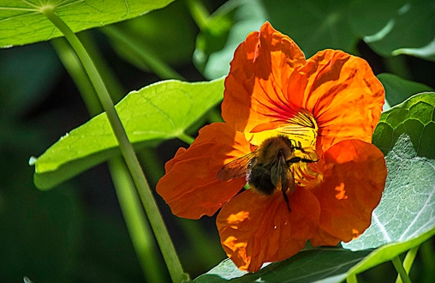 | 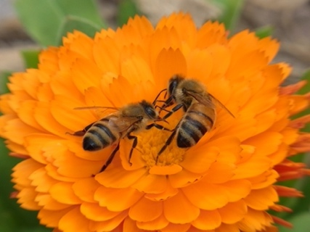

- I’m sure you all know that without bees we would not have fruit or flowers. They are ESSENTIAL for life on earth as we know it, without them, we wouldn't have potatoes, strawberries, tomatoes, coffee, chocolate or cotton!

- You’re ‘small act for the good of many’ is to plant some flower seeds that Bees love. This will help feed the bees and keep them healthy enough to do the ESSENTIAL pollinating.

In your activity packs you have at least 2 LARGER seeds and some smaller seeds too.
You also have 2 biodegradable plant pots.
You can also use empty yoghurt pots or plant pots from home.

WHAT TO DO:

- You will need to fill each pot with compost or garden soil (if you have some empty plastic pots you can use these).
- Place one of the larger seeds in each pot and a divide the smaller seeds so you have a few in each pot too.
- Press the seed lightly into the compost.
- Water your seeds and place them on a plate or tray on a sunny windowsill. Watch them daily and water them regularly, do not let the compost dry out.

In just over a week, you should see your seedlings starting to grow.
If they are growing too big for the pot you may need to put them into a bigger pot/yoghurt pot.
- When you think the last frosts have gone, (late May), Plant them into the ground in a sunny position and keep watering them for a few weeks.
- Now watch and enjoy as the bees find them and enjoy a feast.
Maybe take some pictures of your bees and identify which kind of Bee they are.

https://www.natgeokids.com/uk/discover/animals/insects/honey-bees/

